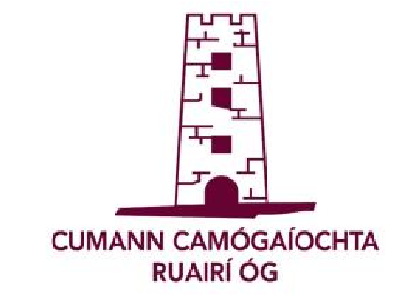 | Cumann Camógaíochta Ruairí Óg  Annual General Meeting  Friday 6th December 2019  7.00pm Club Rooms
PROPOSALS
(A)________________________________________________
__________________________________________________
__________________________________________________ __________________________________________________
Proposer:__________________Seconder:__________________________
(B)________________________________________________
__________________________________________________
__________________________________________________ __________________________________________________
Proposer:_______________________Seconder:__________________________

RECOMMENDATIONS
(A)________________________________________________
__________________________________________________
__________________________________________________ __________________________________________________
Proposer:__________________Seconder:__________________________
(B)________________________________________________
__________________________________________________ __________________________________________________
Proposer:_______________________Seconder:__________________________

RETURN COMPLETED FORMS TO CLUB SECRETARY NO LATER THAN
SATURDAY 30TH NOVEMBER 2019

